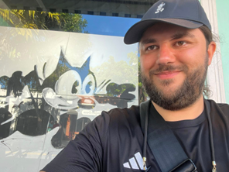 | Tomas  - Roberts  2D ANimator
CONTACT  129 Penycae Rd  Port Talbot  SA13 2EG  Mail:Tomasjroberts@gmail.com  Tel:07938542530  Tomasjroberts.wixsite.com/My-Site  Software  Proficient in the following:  - Procreate  - Adobe packages  - Toonboom  - Moho  - TV Paint  Creative  As a freelance animator I am fully flexible and open to any suggestions from clientele to bring their vision to life, I will work closely to make your designs come to life. | Education  Moho Course-Cardiff  1 Week animation to learn Moho animation software – February 2025  Toonboom course-Cardiff  1 Week animation course to learn Toonboom animation software – February 2025  University of South Wales|Cardiff  Master’s Degree in Animation-2021-2023  BA (Hons) Degree in Animation-2019-2021  Bridgend College|Bridgend, Wales  Foundation Degree in Graphic communication-2017-2019  Experience  June 2025 – August 2025  Animation and Design Internship with Paper Brain Animation  May 2023 - to present  Freelance-Animator-Character and Design for BAFTA award winning show, The Golden Cobra (BBC)  May 2022-November 2024  Illustrator and Animator for Afrosheep Animation  July 2024- December 2024  Supported with Commissions for two IG users to produce illustrations for enamel badges.  References  [Available upon request]

